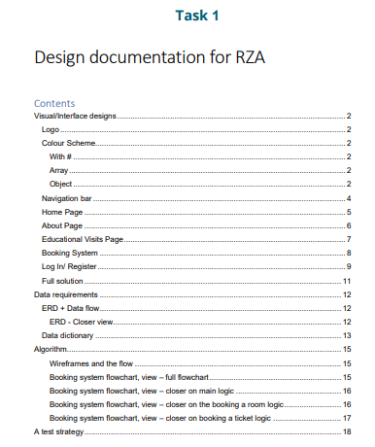

Here’s a paraphrased version of the contents page:

Table of Contents

Design and Interface Elements .................................................................................... 2

Branding and Logo ........................................................................................................ 2

Color Palette .................................................................................................................. 2

Hashtag Usage ............................................................................................................. 2

Array Data Structure .................................................................................................... 2

Object-Oriented Design ............................................................................................... 2

Website Navigation ...................................................................................................... 4

Main Page Layout .......................................................................................................... 5

Company Overview Page ............................................................................................... 6

Educational Visits Information .................................................................................... 7

Reservation System ....................................................................................................... 8

User Login/Registration Section ................................................................................. 9

Complete Solution Overview ....................................................................................... 11

Data Specifications ...................................................................................................... 12

Entity Relationship Diagram (ERD) + Data Flow Analysis ......................................... 12

Detailed ERD View ....................................................................................................... 12

Data Terminology Guide ............................................................................................... 13

Computational Algorithm ............................................................................................. 15

Wireframe Designs and User Flow ............................................................................ 15

Reservation System Full Flowchart ............................................................................ 15

Detailed Flowchart of Core Logic ................................................................................ 16

Detailed Flowchart of Room Booking Logic ............................................................... 16

Detailed Flowchart of Ticket Booking Logic .............................................................. 17

Testing Strategy and Approach ................................................................................... 18

Next page – Visual Interface Designs

Logo

* Create using canva
* Talk about the inspiration and how you came up with it.
* Is the logo sensible for the target audience?

Color Scheme

* Conduct research into the industry
* Use [Coolors - The super fast color palettes generator!](https://coolors.co/)
* Think about the market it is based in and if it resembles it

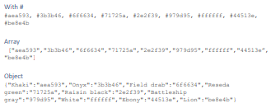

1. **Go to WebAIM's Contrast Checker**:
   1. Visit WebAIM Contrast Checker.
2. **Input Your Colors**:
   1. Enter the hex codes for your foreground (white) and background (ebony) colors.
3. **Check Results**:
   1. The tool will display the contrast ratio and indicate whether it meets WCAG AA or AAA standards.

By consistently checking your color combinations, you ensure that your design is accessible to all users, which is a key aspect of inclusive design.

* **Contrast Ratio**: Ensuring text has sufficient contrast against its background to be readable.

Then create the navigation bar (iconfinder)

* The upcoming pages showcase all the designs I have created using Figma. However, some aspects may be refined as the prototype development progresses. For example, the booking system is more complex than it appears in the UI designs, so modifications will be necessary to align it with the backend during development.

Data Requirements ERD+Data Flow

(using drawsql)

**Entities & Attributes:**

* **Users** (user_id, name, email, password, registration_date)
* **Consultations** (consultation_id, user_id, date, time, service_type)
* **Energy Products** (product_id, name, category, description, price)
* **Carbon Footprint** (record_id, user_id, energy_usage, footprint_value, date_recorded)
* **Energy Tracking** (track_id, user_id, usage_data, date_recorded)

#### **Relationships:**

* A **User** can **schedule** multiple **Consultations**.
* A **User** can **calculate** their **Carbon Footprint**.
* A **User** can **track** their **Energy Usage**.
* The **Energy Products** database provides information for users.

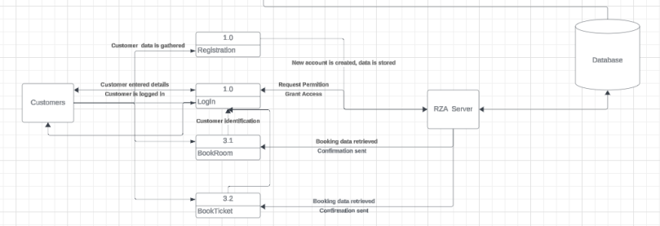Use lucid charts

Then create DATA DICTIONARIES IN THE DATABASE

Using phpmyadmin.

